Fractions
Making Equivalent fractions
In order to make equivalent number, we have to multiply both the numerator and the denominator by the same number. For eg we get the following fractions when we keep on dividing both the numerator and the denominator by the number 2.
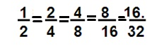
These fractions are equivalent since all of them can be reduced to the simplest fraction - ½.
Equivalent fraction can also be made by dividing both the numerator and the denominator by the same number.
It is important to note that the number by which we divide has to be such that the number divides both the numerator and the denominator perfectly.
Therefore, we can first find the HCF of the numerator and the denominator then divide them by the HCF.
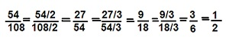
These fractions are equivalent since all of them can be reduced to the simplest fraction- ½.
It is to be remembered that a fraction is said to be in the simplest (or lowest) form if its numerator and denominator have no common factor except 1. For e.g. ½.
Problem: Write the fractions. Are all these fractions equivalent?
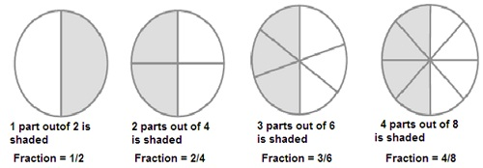
Solution:
1/2 = 2/4 = 3/6 = 4/8 = ½
All these fractions are equivalent since all these fractions can be reduced to the simplest fraction of the value ½.
Problem: Find the equivalent fraction of 36/48 with a) numerator 9 b) denominator 4
Numerator of the value 9 can be obtained by dividing both the numerator and the denominator by 4 since the numerator, 36/4 =9.
36/4 = 9/12
48/4
Denominator of the value 4 can be obtained by dividing both the numerator and the denominator by 12 since the denominator,
48/12 = 4.
= 36/12 = 3/4
48/12

